// oude afbeelding

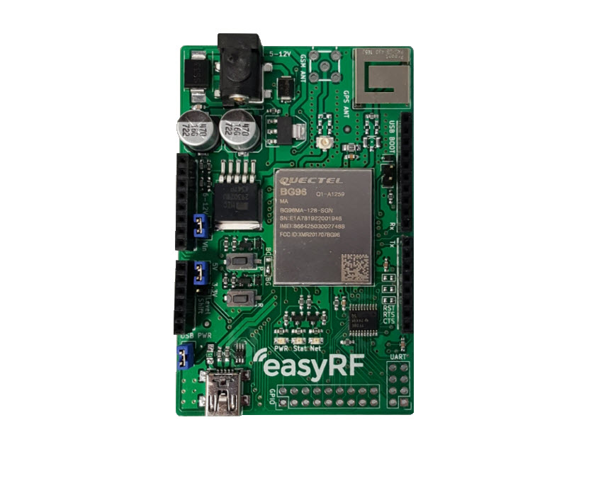

|  |  |
| --- | --- |
| **Document Information** | |
| **Title** | **ERF3000v2** |
| **Subtitle** | **LTE Cat. M1, Cat. NB1, EGPRS & GNSS Arduino Shield** |
| **Document type** | **Preliminary Datasheet** |
| **Document number** | **1** |
| **Revision and date** | **R1 12-06-2019** |

**Product status**

In production

**this document applies to the following products:**

|  |  |  |  |
| --- | --- | --- | --- |
| **Name** | **Type number** | **version** | **Product status** |
| **ERF3000** | **ERF3000** | **1.5** | EOL |
| **ERF3000v2** | **ERF3000** | **1.0** | In production |

**Contents**

**1 Functional description** 4

**1.1 Product overview** 4

**1.2 Product features** 4

**2 Pin Assignment** 6

**2.1 Arduino headers** 6

**2.2 UART header** 7

**2.3 GPIO header** 7

**3 Interfaces** 8

**3.1 Power** 8

**3.1.1 Power headers** 8

**3.2 Antennas** 9

**3.2.1 GNSSS_ANT** 9

**3.2.2 GSM_ANT (ERF4061 GSM antenna)** 9

**3.3 Status LED’s** 9

**3.4 SIM interface** 10

**3.5 UART interface** 11

**3.6 PCM and I2C interface** 11

**3.7 ADC interface** 12

**3.8 GPIO** 12

**4 Electrical specification** 13

**5 Mechanical specifications** 13

**6 Product handling** 14

**7 Related documents** 14

**8 About easyRF** 14

**9 Ordering information** 14

**10 Technical support** 14

# **1 Functional description**

## **1.1 Product overview**

The ERF3000 Arduino shield is a series of LTE Cat.M1/Cat.NB1/EGPRS module offering a maximum data rate of 375kbps downlink and uplink. It features ultra-low power consumption, and provides pin-to-pin compatibility with an Arduino UNO.

The Quectel BG96 module on the Arduino shield can be replaced with the Quectel LTE module EG91/EG95, Cat.NB1 (NB-IoT) module BC95-G, UMTS/HSPA module UG95/UG96 and GSM/GPRS module M95.

A rich set of Internet protocols, industry-standard interfaces (USB/UART/I2C/Status Indicator) and abundant functionalities (USB drivers for Windows XP, Windows Vista, Windows 7/8/8.1/10, Linux and Android) extend the applicability of the module to a wide range of M2M applications such as wireless POS, smart metering, tracking, etc.

The ERF3000 combines the Power of the BG96 with an easy to use Arduino platform and allows for rapid testing and development.

## **1.2 Product features**

|  |  |  |  |
| --- | --- | --- | --- |
| **General features** | | | |
| **Frequency band** | **BG96-G** | **Cat-M1/ NB1** | LTE FDD: B1/B2/B3/B4/B5/B8/B12/B13/B18/B19/B20/B26/B28  LTE TDD: B39 (for CAT-M1 Only) |
| **EGRPS** | 850/900/1800/1900MHz |
| **LTE version** | | | 3GPP E-UTRA release 13 |
| **GNSS** | | | GPS, GLONASS, BeiDou/Compass, Galileo, ZSS |
| **Supply voltage range (BG96)** | | | 3.3V~4.3V, 3.8V typ. |
| **Operation temperature** | | | -40°C~+85°C |
| **PCB dimensions** | | | 57.2 x 84.2 mm (± 0.1) |
| **Weight** | | | Approx. 30 g |
| **Control via AT commands** | | | Through Arduino “Software Serial” interface , of through the USB interface on the shield |

|  |  |  |
| --- | --- | --- |
| **Specifications** | | |
| **SMS** | | Point to point MO and MT  SMS cell broadcast  Text and PDU mode |
| **Data** | **Cat M1** | Max. 375Kbps (DL), Max. 375Kbps (UL) |
| **Cat NB1** | Max. 32Kbps (DL), Max. 70Kbps (UL) |
| **EDGE** | Max. 296Kbps (DL), Max. 236.8Kbps (UL) |
| **GPRS** | Max. 107Kbps (DL), Max. 85.6Kbps (UL) |
| **Protocols** | | PPP/TCP/UDP/SSL/TLS/FTP/HTTP(S)/NITZ/PING/MQTT |
| **Interfaces** | | |
| **USB** | | 2.0 High speed up to 480Mbps |
| **UART** | | 3x |
| **PCM** | | 1x |
| **ADC (15 bits)** | | 2x |
| **GPIO** | | 2x (I2C and UART3 can be re-configured as extra 4 GPIOs) |
| **USIM** | | 1 x (1.8V/3.0V) |
| **NETLIGHT** | | Network Status Indication |
| **STATUS** | | Power ON/OFF Status Indication |

|  |  |  |  |
| --- | --- | --- | --- |
| **Electrical characteristics (BG96 module)** | | | |
| **Output power** | | | Max. Power: 23dBm |
| **Consumption** | **LTE Cat M1 (typical)** | **Power saving mode** | 10uA |
| **Idle State** | 16mA @DRX=1.28s  15mA @e-I-DRX=20.48s |
| **Sleep State** | 1.7mA @DRX=1.28s  1.1mA @e-I-DRX=20.48s |
| **LTE Connected Mode (Avg.)** | 124mA @0dBm  130mA @10dBm  190mA @23dBm |
| **LTE Cat NB1 (typical)** | **Power saving mode** | 10uA |
| **Idle State** | 16mA @DRX=1.28s  15mA @e-I-DRX=20.48s |
| **Sleep State** | 2.3mA @DRX=1.28s  1.7mA @e-I-DRX=20.48s |
| **LTE Connected Mode (Avg.)** | 65mA @0dBm  66mA @10dBm  78mA @23dBm |
| **Sensitivity** | | | -107dBm @Cat M1, 1.4MHz Bandwidth, CE Mode A  -113dBm @Cat NB1, CE Level 0 |

# **2 Pin Assignment**

## **2.1 Arduino headers**

The ERF3000 shield is designed to be an Arduino shield. Below, the interface to the Arduino board can be found.

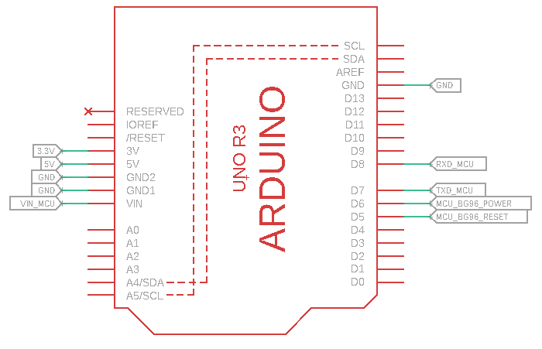**I/O Parameter Definition**

|  |  |
| --- | --- |
| **Type** | **Description** |
| **IO** | **Bidirectional** |
| **DI** | **Digital input** |
| **DO** | **Digital output** |
| **PI** | **Power input** |
| **PO** | **Power output** |
| **AI** | **Analog input** |
| **AO** | **Analog output** |
| **OD** | **Open drain** |

|  |  |  |  |  |
| --- | --- | --- | --- | --- |
| **Header** | **Name** | **Power domain** | **I/O** | **Description** |
| **Arduino header** | **3.3V** | **3.3V** | **PI** | **3.3V input level shifter reference voltage** |
| **Arduino header** | **5V** | **5V** | **PI** | **5V input level shifter reference voltage** |
| **Arduino header** | **GND** | **-** | **-** | **Ground** |
| **Arduino header** | **GND** | **-** | **-** | **Ground** |
| **Arduino header** | **VIN_MCU** | **5V to 12V** | **PI** | **External input to power shield (recommended minimal 5V, 2A)** |
| **Arduino header** | **GND** | **-** | **-** | **Ground** |
| **Arduino header** | **RXD_MCU** | **V_level_shifter** | **DI** | **Receive data** |
| **Arduino header** | **TXD_MCU** | **V_level_shifter** | **DO** | **Transmit data** |
| **Arduino header** | **MCU_BG96_POWER** | **3.3V** | **DI** | **Turn module On/Off (active high)** |
| **Arduino header** | **MCU_BG96_RESET** | **3.3V** | **DI** | **Reset module (active high)** |

## **2.2 UART header**

The UART header is connected to all UART1 interface related I/O’s from the Quectel module on the shield. All these signals are routed through the level shifter. Depending on the position of the level shift header, the voltage of the signals will be 3.3V or 5.0V.

|  |  |  |  |  |  |
| --- | --- | --- | --- | --- | --- |
| **Header** | **Pin No.** | **Name** | **Power domain** | **I/O** | **Description** |
| **UART** | **1** | **RI** | **V_level_shifter** | **DO** | **Ring indicator** |
| **UART** | **2** | **DCD** | **V_level_shifter** | **DO** | **Data carrier detection** |
| **UART** | **3** | **RTS** | **V_level_shifter** | **DI** | **Request to send** |
| **UART** | **4** | **CTS** | **V_level_shifter** | **DO** | **Clear to send** |
| **UART** | **5** | **TXD** | **V_level_shifter** | **DO** | **Transmit data** |
| **UART** | **6** | **RXD** | **V_level_shifter** | **DI** | **Receive data** |
| **UART** | **7** | **DTR** | **V_level_shifter** | **DI** | **Data terminal ready (Sleep mode control)** |
| **UART** | **8** | **GND** | **GND** | **-** | **Ground** |

## **2.3 GPIO header**

The GPIO header is connected to all the GPIO related I/O’s from the Quectel module on the shield.

|  |  |  |  |  |  |
| --- | --- | --- | --- | --- | --- |
| **Header** | **Pin No.** | **Name** | **Power domain** | **I/O** | **Description** |
| **GPIO** | **1** | **PSM_IND** | **1.8V** | **DO** | **Power saving mode indicator** |
| **GPIO** | **2** | **ADC1** | **0.3V to 1.8V** | **AI** | **Analog to digital converter** |
| **GPIO** | **3** | **PCM_CLK** | **1.8V** | **DO** | **PCM clock output** |
| **GPIO** | **4** | **PCM_SYNC** | **1.8V** | **DO** | **PCM frame synchronization output** |
| **GPIO** | **5** | **PCM_DIN** | **1.8V** | **DI** | **PCM data input** |
| **GPIO** | **6** | **PCM_DOUT** | **1.8V** | **DO** | **PCM data output** |
| **GPIO** | **7** | **GPIO** | **1.8V** | **IO** | **General purpose input / output** |
| **GPIO** | **8** | **W_DISABLE#** | **1.8V** | **DI** | **Airplane mode control** |
| **GPIO** | **9** | **AP_READY** | **1.8V** | **DI** | **Application processor sleep state detection** |
| **GPIO** | **10** | **DBG_RXD** | **1.8V** | **DI** | **Receive data** |
| **GPIO** | **11** | **DBG_TXD** | **1.8V** | **DO** | **Transmit data** |
| **GPIO** | **12** | **ADC0** | **0.3V to 1.8V** | **AI** | **Analog to digital converter** |
| **GPIO** | **13** | **GPIO** | **1.8V** | **IO** | **General purpose input / output** |
| **GPIO** | **14** | **Reserved** | **-** | **-** | **Keep this pin open** |
| **GPIO** | **15** | **UART3_RXD** | **1.8V** | **DI** | **Receive data** |
| **GPIO** | **16** | **UART3_TXD** | **1.8V** | **DO** | **Transmit data** |
| **GPIO** | **17** | **I2C_SDA** | **1.8V** | **OD** | **I2C serial data (external pull-up resistor is required)** |
| **GPIO** | **18** | **I2C_SCL** | **1.8V** | **OD** | **I2C serial clock (external pull-up resistor is required)** |

# **3 Interfaces**

## **3.1 Power**

The ERF3000 shield must be supplied through the shield barrel jack (5V to 12V DC) Voltage must be stable during module operation, taking into account that the current drawn from VCC pins may vary significantly based on the power consumption profile of the IoT system.

The power adapter supplied with the shield is CUI part SWI10-5-E-P5. This is a 5V, 2A power adapter with a maximum power of 10W.

Alternatively the shield can be powered by an external source through the VIN pin*.

*Please see chapter 2.1 Arduino headers for more details.

When powering the shield through the VIN pin, please keep in mind the voltage must be stable and can’t exceed 12V. Also please be cautious when an Arduino Uno is used to supply the shield. The Arduino UNO can only supply 500mA max. the shield can draw up to 2A, and in this process the Arduino UNO can be damaged.

## **3.1.1 Power headers**

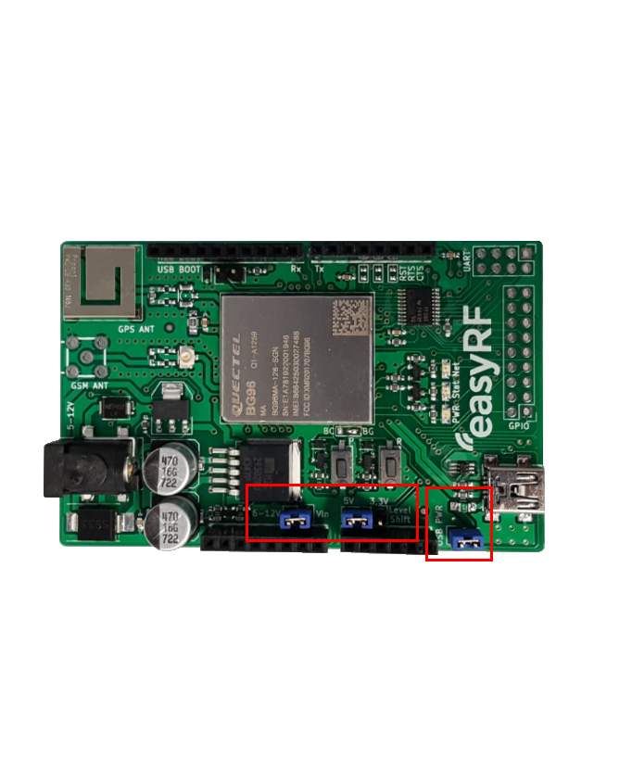The Shield has 3 important power headers, the VIN header, the level shift header and the current measurement header. These are marked with a red box on the following picture:

The VIN header must be closed when the shield is supplied through the VIN pin on the Arduino header.

The level shift header must be placed on either 3.3V or 5V, this depends on the microprocessor board used in combination with the shield.

At last an additional header can be soldered on the shield to measure the consumed current by the Quectel module*.

*For more information regarding the current measurement, please see the [ERF3000_User_guide_v1.0.pdf](ERF3000v2%20User_Guide_V1.0.docx).

## **3.2 Antennas**

The ERF3000 uses 2 antennas, 1 GPS antenna and 1 GSM antenna.

The GPS antenna is integrated on the PCB and the GSM antenna needs to be connected to the U.fl connector.

It is important to note that the antennas can’t be too close to one another, because they will cause interference. This causes problems when using the GPS function of the shield.

## **3.2.1 GNSSS_ANT**

The ProAnt 430 antenna is an onboard (TM) SMD, GPS/GLONASS antenna.

The GPS antenna has been tuned with a LC Chebyshev filter to gain optimal performance.

The center frequency is around 1575 MHz.

## **3.2.2 GSM_ANT (ERF4061 GSM antenna)**

The ERF4061 antenna is a GSM PCB antenna. The antenna can be used in the frequency band of 800~900 / 1500 / 2100~2300 MHz. The antenna can be used for applications, GSM, M2M, NB-IoT and CAT-M.

For more information see ERF4061 datasheet

## **3.3 Status LED’s**

The shield also has 3 LED’s to give an indication of the status of the shield.

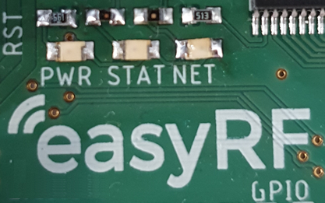

|  |  |  |  |
| --- | --- | --- | --- |
| **Led** | **Color** | **State** | **Description** |
| **PWR** | **Green** | **Always on** | **Shield is powered** |
| **Always off** | **Shield is not powered** |
| **STAT** | **Red** | **0.2s on/1.8 off** | **Searching for network** |
| **1.8s on/0.2s off** | **Connected to network** |
| **0.125s on/0.125s off** | **Data transfer is ongoing with a network** |
| **NET** | **Yellow** | **Always on** | **Registered on network** |
| **Always off** | **Not registered on network** |

## **3.4 SIM interface**

To register and connect to a network, a SIM card needs to be inserted and activated.

When an activated SIM is inserted, the functionality of the SIM card should be checked with AT+CIMI and AT+QCCID.*

The Attend model number of the SIM card socket is 115U-A000.

*For more information see: Quectel_BG96_AT_Commands_Manual.pdf

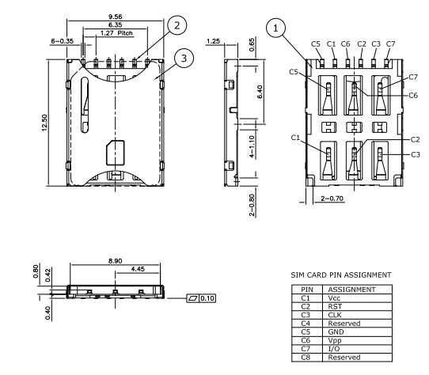

## **3.5 UART interface**

The ERF3000 shield provides 3 UART ports:

|  |  |  |
| --- | --- | --- |
| **Interface** | **Supported Baud rates** | **Description** |
| UART1 | 9600, 19200, 38400, 57600, 115200, 230400, 460800 and 921600bps (115200 is the default value) | The main UART port, this is used for data transmission and AT command communication |
| UART2 | 115200bps | The debug UART port, used for debugging and log output |
| UART3 | 115200bps | The GNSS UART port, used for outputting GNSS and NMEA sentences |

The UART1 interface can be found on the UART header. All signals are routed through a level shifter. The voltage of the signals can either be 3.3V or 5.0V. this is dependent on the position of the level shift header.

Both UART2 and 3 can be found on the GPIO header, and are both in the 1.8V domain.

Please see chapter 2.2 UART header and 2.3 GPIO header for more details regarding the exact location of the UART signals.

## **3.6 PCM and I2C interface**

The BG96 provides one Pulse Code Modulation (PCM) digital interface and one I2C interface. These can for example be used in combination with an audio codec.

In below image an example provided by Quectel is shown of how an audio codec can be implemented.

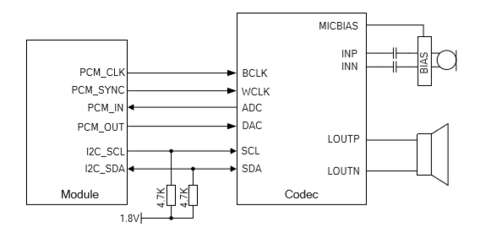

## **3.7 ADC interface**

The BG96 provides two analog-to-digital (ADC) interfaces. The voltage on these interfaces can be read with the AT+QADC command. For ADC0 use AT+QADC=0 and for ADC1 use AT+QADC=1.

|  |  |  |  |
| --- | --- | --- | --- |
| **Parameter** | **Min.** | **Max.** | **Unit** |
| ADC0 Voltage Range | 0.3 | 1.8 | V |
| ADC1 Voltage Range | 0.3 | 1.8 | V |
| ADC Resolution | - | 15 | bits |

## **3.8 GPIO**

The module also provides 2 GPIO interfaces. these can be controlled with the AT+QFWD=”GPIO” command.

"gpio",<mode>,<pin>[,[<dir>,<pull>,<drv>]/[<val>][,<save>]]

# **4 Electrical specification**



A power supply with 5 ~ 12V DC output with a minimum of 2A is needed to power the shield.

12V is the absolute max, do not exceed this.

The power must be supplied to the DC jack located on the shield or to the Arduino DC jack*.

*Please see chapter 3.1 Power for the power options.

# **5 Mechanical specifications**

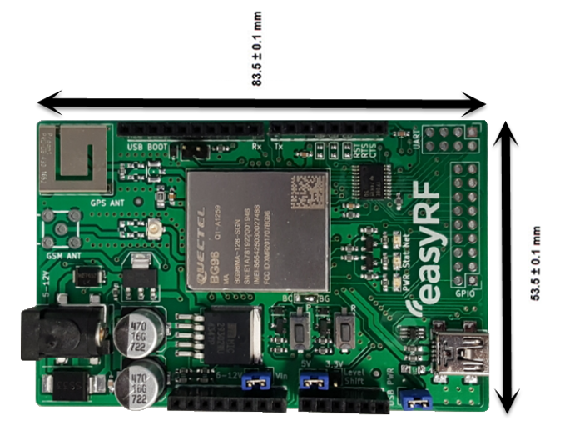

|  |  |
| --- | --- |
| **Hardware** | **Height** |
| Shield + Arduino | 27.5 ±0.1 mm |
| Shield wit header pins | 23.0 ±0.1 mm |
| Shield without header pins | 12.0 ± 0.1 mm |

# **6 Product handling**

Handle with ESD safety care.

# **7 Related documents**

|  |  |
| --- | --- |
| **Document** | **Distributor** |
| ERF4061 Datasheet.pdf | easyRF |
| Quectel_BG96_AT_Commands_Manual_V2.3.pdf | Quectel |
| ERF3000V2_User_Guide_V1.0.pdf | easyRF |

# **8 About easyRF**

easyRF is supplier and manufacturer of wireless communication solutions with an easy-to-use approach, targeting different applications and markets. The products are standard off-the-shelf products, but customization of the products is possible.  
  
easyRF is successful in the a wide range of markets, such as: industrial, agriculture, security, building automation.

# **9 Ordering information**

Please check [www.easyRF.eu](http://www.easyRF.eu) or [www.TOP-electronics.com](http://www.TOP-electronics.com) for more information.

The shield is available as the following packages:

|  |  |  |  |
| --- | --- | --- | --- |
| **Package** | ERF3000 | ERF3001 | ERF3000v2 |
| **Includes** | - BG96 Arduino shield  - GSM antenna  - Power adapter | - BC95-B8/B20 Arduino shield  - GSM antenna | - BG96 Arduino shield  - GSM antenna  - Power adapter |

# **10 Technical support**

For all product related questions please contact us via [info@easyRF.eu](mailto:info@easyRF.eu)

Or through our distributor, TOP-electronics via [support@top-electronics.com](mailto:support@top-electronics.com)